POSITION DESCRIPTION
Position Name | Registered Nurse - Naroo
Position Number | To be completed
TRIM Reference
Reports to | Naroo and Aged Services Manager
Classification | Local Government Aged, Disability and Home Care (State) Award  Grade is variable depending on duties assigned
Term of Employment: | Permanent Part Time / Full Time
Approximate number of direct reports: | Nil
Location: | Naroo Hostel Warialda, NSW
Operational Expenditure: | Nil
Capital Expenditure: | Nil
Delegations | In accordance with Council’s Delegations Register

Overview of the Gwydir Shire Council

Located on the Fossickers Way between the New England and North West regions of NSW, the Gwydir Shire encompasses a diverse landscape that is both picturesque and productive. With affordable housing, a strong sense of community and diverse leisure and recreation activities, the Shire offers an idyllic and fulfilling lifestyle. Bingara and Warialda are the main towns in the Shire.

The Gwydir Shire Council prides itself on being an award-winning organisation that supports its community through the provision of high-quality services. Council offers employees a rewarding career that allows staff to make a positive impact in the communities in which they live; and provides exciting opportunities to explore and nurture career avenues within the organisation. Council strongly supports a flexible-family friendly work environment.

Council’s vision is to be a recognised leader in Local Government through continuous learning and sustainability. Council embraces this mantra by ensuring all staff have access to training and education, in order to reach their full potential.

Our Vision

To be the recognised leader in Local Government through continuous learning and sustainability.

Our Mission

To ensure that the Council’s long-term role is viable and sustainable by meeting the needs of our residents in a responsible caring way, attract sustainable development while maintaining the traditional rural values, character and culture of our people.

Our Values

1. For Our Community and Visitors
We will provide a safe, clean and healthy environment in which all people have the opportunity to participate, and share in the Council’s services and facilities.

2. For Our Community Committees
We will seek their opinion in relation to the services in which they assist us, offer relevant and timely support, and recognise their valuable contribution.

3. For Our Staff
We will create an atmosphere of team support, which encourages frank and honest communication, and the use of common sense and innovation in a safe and friendly working environment with the aim of efficiency.

4. For Our Councillors
We will treat all Councillors equally and ensure that they are provided with accurate and timely advice and expect that they will treat each other and the staff with due respect.

Core Responsibilities of Employees

Council has core responsibilities and it is a requirement that all employees will adhere to Council’s current guiding behaviour standards and expectations. In particular, but not exclusive too, the following:
Work Health and Safety
- Ensure that all employees fulfil their specific responsibilities, duties and due diligence requirements under the NSW Work, Health & Safety legislation and Council's relevant safe work instructions, policies and procedures.
- Ensure that Workplace Health and Safety is always at front of mind and a number one priority, working with care and consideration to safeguard the health and safety of all staff and members of the general public.
- Follow safe practices/procedures to perform duties in a manner so as not to put yourself or others at risk of harm.
- Immediately report any hazards, incidents and accidents to the relevant supervisor and take appropriate action.
- Participate in delivering a positive safety culture, including having a proactive involvement in reviewing safe systems of work compliance and the implementation of continuous improvements in health and safety.
Community and Customer Focused
- Convey a professional image of Council at all times.
- Provide customer centred services in line with organisational objectives and agreed service standards which is focused on continuous improvement
- Deliver quality customer service and service delivery which exceeds community expectations.
Code of Conduct, Anti-Discrimination and Equal Employment Opportunity
- Comply with all legislative requirements of the role.
- Store and maintain corporate records in Council’s electronic document management system in accordance with relevant protocols, procedures and the State Records Act.
- Convey a professional and positive image of Council and the local government sector at all times, including dressing appropriately for the role and wearing designated uniform (Personal Protective Equipment) if required.
- Support and promote a professional working environment free from discrimination, harassment and victimisation. It is the responsibility of all employees to ensure that proper standards of conduct are upheld in the workplace.
- Eliminate and ensure the absence of discrimination in employment on the grounds of race, sex, marital or domestic status and disability in councils, and promote equal employment opportunity for women, aboriginal and Torres Strait Islander people, people from a non-english speaking background, and persons with disabilities.
Work Performance
- Productively and cooperatively contribute to the outcomes of work teams.
- Attend and positively contribute to team meetings.
- Take responsibility for and manage own work and contribute to a productive team and work environment.
- Work cooperatively and proactively to achieve the objectives of Council’s Plans and the priorities identified in the Community Strategic Plan.
- Regularly review and appraise own performance against required levels.
- Proactively engage in a performance planning and review process on a regular basis in line with Council policy.
Innovation
- To identify new and improved ways to do business.
- Fostering continuous improvement in all areas of operations and service delivery.
- Actively share information and knowledge on issues, training and practices with relevant staff.
- Identify and subsequently remove, mitigate against or minimise exposures to risk when introducing new and improved work practices.
Department and Branch Description
Forming part of the Organisation and Community Services Department, the Naroo and Aged Care Services Branch is responsible for providing aged care services including hostel services, Commonwealth Home Support Program (CHSP) services and community transport.
Primary Purpose of the Position
To provide Registered Nursing duties to care for older people and people with disabilities that are receiving residential care in Naroo Hostel after being assessed by Aged Care assessment Team.
Key Position Accountabilities
- Be Aware of individual responsibilities as an RN in relation to the Work, Health and Safety Act, Infection Control Regulations, Fire, Security and Safety Procedures, Disaster and Emergency Procedures.
- Maintain confidentiality of all residents and staff at Naroo Hostel.
- Demonstrate effective communication through established channels.
- Participate in regular Staff Development Reviews in consultation with management.
- Demonstrate commitment to continuous improvement and participate in auditing programs.
- Manage resident care and ensure that care staff adhere to care plans.
- Manage the Infection Control surveillance program and ensure that it is practised.
- Review all care plans on a rotational basis and as required.
- Identify resident care needs and implement requirements.
- Initiate or preform resident assessments.
- Maintain necessary documentation relating to resident’s care needs.
- Ensure records are continually reviewed and updated.
- Work in partnership with the Hostel Manager to ensure quality service delivery.
- Be familiar with accreditation and certification standards.
- Submit regular reports to staff meetings.
- Communicate/liaise with health care agencies/professionals (Doctors, Specialists, Pharmacists).
- Liaise with residents and their families or representatives regarding care resident’s needs when required.
- Ensure protective clothing and/or equipment is utilised as required.
- Monitor resident access to doctor.
- Ensure medication is managed according to Accreditation Standards
- Complete staff clinical competencies routinely.
- Review incidents and dressings
- Manage immunisation programme (staff & residents)
- Monitor continence aid requirements by residents and implement change as required.
- Carry out all RN directives in a timely manner eg massage
- Run staff information sessions eg wounds, infection control
- Perform care in accordance with Resident Care Plan, Naroo Hostel Procedure Manuals, policies, industry policies and duty statements ensuring that all tasks are completed in accordance with skills, experience and qualifications and seek assistance with any procedure or aspect of resident care if lacking competence, knowledge or confidence to perform same.
- Ensure all written communication is legible, factual, and non-judgemental and meets all legal and policy requirements.
- Make a conscious effort to maintain expenditure and judicious use of equipment and resources within the Hostel’s budget.
- Treat residents with respect at all times, ensuring their dignity and self-esteem is maintained and that they receive the quality of care consistent with The Standards and Accreditation Polices reporting any unusual behaviours to the Naroo and Aged Services Manager.
- Willingness to work within the policies, procedures and practices of the residential aged care service and all aspects of regulatory compliance associated with work role.
- Actively participate in continuous quality improvement and Accreditation activities and contribute to staff and quality meetings in a constructive and effective manner.
- Act in accordance with the Naroo Above and Below the line behaviours and Gwydir Shire Code of Conduct.
All positions in Council involve multi-skilling and consequently the interchange of duties where and when required for the effective operation of the Department. The duties described above are indicative of the primary duties that a person appointed to the position would be expected to perform and should not be regarded as the sole duties applicable to the position. Other duties may be assigned in accordance with skills, competence and training.

Capabilities for the role
Below is the full list of capabilities and the level required for this position. The capabilities in bold are the focus capabilities for this position. Refer to the next section for further information about the focus capabilities.
Local Government Capability Framework
Capability Group | Capability Name | Level
Personal attributes | Manage Self | Foundational
 | Display Resilience and Adaptability | Intermediate
 | Act with Integrity | Intermediate
 | Demonstrate Accountability | Foundational
Relationships | Communicate and Engage | Intermediate
 | Community and Customer Focus | Intermediate
 | Work Collaboratively | Foundational
 | Influence and Negotiate | Foundational
Results | Plan and Prioritise | Foundational
 | Think and Solve Problems | Intermediate
 | Create and Innovate | Foundational
 | Deliver Results | Foundational
Resources | Finance | Foundational
 | Assets and Tools | Foundational
 | Technology and Information | Foundational
 | Procurement and Contracts | Foundational

FOCUS CAPABILITIES
Group and capability | Level |  | Behavioural indicators
Personal Attributes  Display Resilience and adaptability | Intermediate |  | - Adapts quickly to changed priorities and organisational settings  - Welcomes new ideas and ways of working  - Stays calm and focused in difficult situations  - Perseveres through challenges  - Offers own opinion and raises challenging issues
Personal Attributes  Act with Integrity | Intermediate |  | - Maintains confidentiality of customer and organisational information  - Is open, honest and consistent in words and behaviour  - Takes steps to clarify ethical issues and seeks advice when unsure what to do  - Helps others to understand their obligations to follow the code of conduct, legislation and policies  - Recognises and reports inappropriate behaviour, misconduct and perceived conflicts of interest
Relationships  Communicate and Engage | Intermediate |  | Focuses on key points and communicates in ‘Plain English’  Clearly explains and presents ideas and technical information  Monitors own and others’ nonverbal cues and adapts where necessary  Listens to others when they are speaking and asks appropriate, respectful questions  Shows sensitivity in adapting communication content and style for diverse audiences
Relationships  Community and Customer Service | Intermediate |  | Identifies and responds quickly to customer needs  - Demonstrates a thorough knowledge of services provided  Puts the customer and community at the heart of work activities  Takes responsibility for resolving customer issues and needs
Results  Think and Solve Problems | Intermediate |  | Gathers and investigates information from a variety of sources  Questions basic inconsistencies or gaps in information and raises to appropriate level  Asks questions to get to the heart of the issue and define the problem clearly  Analyses numerical data and other information and draws conclusions based on evidence  Works with others to assess options and identify appropriate solutions
Resources  Technology and Information | Foundational |  | Shows confidence in using the technology required for the role  Uses technology appropriately, in line with acceptable use policies  Completes work tasks in line with records, information and knowledge management policies

Qualifications
Current Nurses Registration Certificate
Other requirements of the Position
- Drivers Licence - possession of a current valid Class C Driver’s Licence.
- Computer skills including the ability to write and format documents (Microsoft applications), produce power point presentations, and use spreadsheets.
- Willingness to work flexible hours to meet the requirements of the position.
- Behaviour in accordance with Council’s policies and the Code of Conduct.
- Report environment issues that may become evident when carrying out the position duties.
- Willingness to have Council conduct a Criminal History Check.
- Agree to undertake a medical assessment by Council’s nominated medical practitioner if required and to be medically fit to undertake the full requirements of the position.
Selection Criteria
Applicants for the position are required to address all of the Essential and Desirable Selection Criteria.
Essential

- Current Nurses Registration Certificate
- First aid certificate with CPR
- Demonstrated personal competencies, including confidentiality, effective communication skills (written, verbal and non-verbal), ability to successfully negotiate for outcomes, sound decision making skills, and genuine commitment to consultation and engagement with other stakeholders.
- Willingness to actively contribute to continuous quality improvement and Accreditation activities within the service.
- Willingness to work within the policies, procedures and practices of the residential aged care service and all aspects of regulatory compliance associated with work role
- Ability to balance conflicting priorities and work to deadlines.
- Supports productive relationships with a demonstrated ability to work as part of a team and independently and with people at all levels.
- Current valid ‘C’ Class driver’s licence.

Desirable

- Previous experience working within a residential aged care environment would be highly regarded.

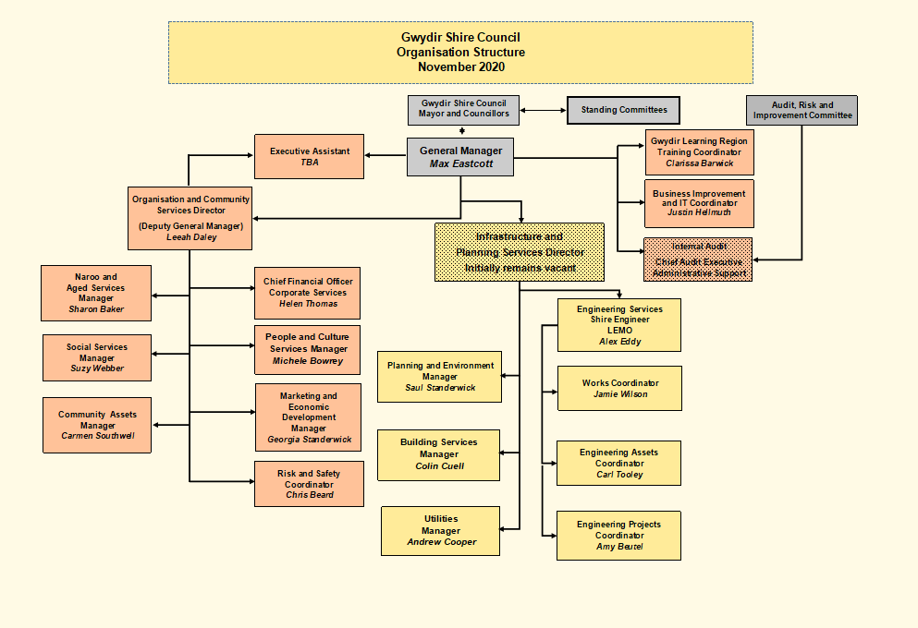
Signature Block

Prepared by | Human Resource Officer
Approved by General Manager
(or delegate) – Name:
Approved by General Manager
(or delegate) - Signature:
Date Approved/Reviewed:
Version Number and Date: | Version 2 – April 2021
Employee Declaration
I agree with and understand the requirements of my employment with Council, as contained in this Position Description.
I declare that I:
- have had the opportunity to ask questions regarding my terms and conditions of employment and received satisfactory responses.
- understand that the Position Description describes in general the nature of my employment and that other duties may be required of me from time to time consistent with my position classification level, experience, and qualifications.

Employee Name (Please Print):
Employee Signature:
Date:

