POSITION DESCRIPTION
Position Name | Early Childhood Educator
Position Number | To be completed
TRIM Reference | 21/
Reports to | Director of service
Classification | Local Government (State) Award 2020  Band 1 Level 3 (Grade 3)
Term of Employment: | Permanent full time
Approximate number of direct reports: | Nil
Location: | Variable depending on venue of Mobile Preschool Service
Operational Expenditure: | Nil
Capital Expenditure: | Nil
Delegations | In accordance with Council’s Delegations Register

Overview of the Gwydir Shire Council

Located on the Fossickers Way between the New England and North West regions of NSW, the Gwydir Shire encompasses a diverse landscape that is both picturesque and productive. With affordable housing, a strong sense of community and diverse leisure and recreation activities, the Shire offers an idyllic and fulfilling lifestyle. Bingara and Warialda are the main towns in the Shire.

The Gwydir Shire Council prides itself on being an award-winning organisation that supports its community through the provision of high-quality services. Council offers employees a rewarding career that allows staff to make a positive impact in the communities in which they live; and provides exciting opportunities to explore and nurture career avenues within the organisation. Council strongly supports a flexible-family friendly work environment.

Council’s vision is to be a recognised leader in Local Government through continuous learning and sustainability. Council embraces this mantra by ensuring all staff have access to training and education, in order to reach their full potential.

Our Vision

To be the recognised leader in Local Government through continuous learning and sustainability.

Our Mission

To ensure that the Council’s long-term role is viable and sustainable by meeting the needs of our residents in a responsible caring way, attract sustainable development while maintaining the traditional rural values, character and culture of our people.

Our Values

1. For Our Community and Visitors
We will provide a safe, clean and healthy environment in which all people have the opportunity to participate, and share in the Council’s services and facilities.

2. For Our Community Committees
We will seek their opinion in relation to the services in which they assist us, offer relevant and timely support, and recognise their valuable contribution.

3. For Our Staff
We will create an atmosphere of team support, which encourages frank and honest communication, and the use of common sense and innovation in a safe and friendly working environment with the aim of efficiency.

4. For Our Councillors
We will treat all Councillors equally and ensure that they are provided with accurate and timely advice and expect that they will treat each other and the staff with due respect.

Core Responsibilities of Employees

Council has core responsibilities and it is a requirement that all employees will adhere to Council’s current guiding behaviour standards and expectations. In particular, but not exclusive too, the following:
Work Health and Safety
- Ensure that all employees fulfil their specific responsibilities, duties and due diligence requirements under the NSW Work, Health & Safety legislation and Council's relevant safe work instructions, policies and procedures.
- Ensure that Workplace Health and Safety is always at front of mind and a number one priority, working with care and consideration to safeguard the health and safety of all staff and members of the general public.
- Follow safe practices/procedures to perform duties in a manner so as not to put yourself or others at risk of harm.
- Immediately report any hazards, incidents and accidents to the relevant supervisor and take appropriate action.
- Participate in delivering a positive safety culture, including having a proactive involvement in reviewing safe systems of work compliance and the implementation of continuous improvements in health and safety.
Community and Customer Focused
- Convey a professional image of Council at all times.
- Provide customer centred services in line with organisational objectives and agreed service standards which is focused on continuous improvement
- Deliver quality customer service and service delivery which exceeds community expectations.
Code of Conduct, Anti-Discrimination and Equal Employment Opportunity
- Comply with all legislative requirements of the role.
- Store and maintain corporate records in Council’s electronic document management system in accordance with relevant protocols, procedures and the State Records Act.
- Convey a professional and positive image of Council and the local government sector at all times, including dressing appropriately for the role and wearing designated uniform (Personal Protective Equipment) if required.
- Support and promote a professional working environment free from discrimination, harassment and victimisation. It is the responsibility of all employees to ensure that proper standards of conduct are upheld in the workplace.
- Eliminate and ensure the absence of discrimination in employment on the grounds of race, sex, marital or domestic status and disability in councils, and promote equal employment opportunity for women, aboriginal and Torres Strait Islander people, people from a non-english speaking background, and persons with disabilities.
Work Performance
- Productively and cooperatively contribute to the outcomes of work teams.
- Attend and positively contribute to team meetings.
- Take responsibility for and manage own work and contribute to a productive team and work environment.
- Work cooperatively and proactively to achieve the objectives of Council’s Plans and the priorities identified in the Community Strategic Plan.
- Regularly review and appraise own performance against required levels.
- Proactively engage in a performance planning and review process on a regular basis in line with Council policy.
Innovation
- To identify new and improved ways to do business.
- Fostering continuous improvement in all areas of operations and service delivery.
- Actively share information and knowledge on issues, training and practices with relevant staff.
- Identify and subsequently remove, mitigate against or minimise exposures to risk when introducing new and improved work practices.
Department and Branch Description
Forming part of the Organisation and Community Services Department, the Social Services Branch is responsible for providing an array of services focusing on the three main target areas of children, youth and families. The Branch is responsible for the management and operational matters associated with youth, families and social services as well as delivering high quality educational and recreational programs, information, Advocacy and referral services.
The Tharawonga Mobile Resource Unit provides centre based day care to the more remote and smaller villages within the Gwydir Shire to ensure that local families have access to early childhood education.
Primary Purpose of the Position
The position is responsible for providing high quality children’s services throughout the villages within the Gwydir Shire to ensure that local families have access to early childhood education providing care for the social, emotional, physical and educational needs of infants and young children.
Key Position Accountabilities
- Provision of education, care and supervision for children participating in the preschool program of tailored activities designed to meet the individual growth and developmental needs.
- Carry out all duties and functions in a manner that promotes a positive attitude, team based approach with strong support for organisational values.
- Assist and perform duties as requested by the Service Director to ensure the efficient daily running of the service ensuring compliance with accreditation requirements.
- Encourage community awareness together with parental involvement and input to ensure a flexible early childhood program supported by all stakeholders.
- Assist with the development and implementation of the programmed activities and group situations.
- Promote the integration of all children, including those with additional needs ensuring participation in the program under the direction of trained staff.
- Maintain a high standard of hygiene and cleanliness in the service.

All positions in Council involve multi-skilling and consequently the interchange of duties where and when required for the effective operation of the Department. The duties described above are indicative of the primary duties that a person appointed to the position would be expected to perform and should not be regarded as the sole duties applicable to the position. Other duties may be assigned in accordance with skills, competence and training.

Capabilities for the role
Below is the full list of capabilities and the level required for this position. The capabilities in bold are the focus capabilities for this position. Refer to the next section for further information about the focus capabilities.
Local Government Capability Framework
Capability Group | Capability Name | Level
Personal attributes | Manage Self | Foundational
 | Display Resilience and Adaptability | Intermediate
 | Act with Integrity | Intermediate
 | Demonstrate Accountability | Foundational
Relationships | Communicate and Engage | Intermediate
 | Community and Customer Focus | Intermediate
 | Work Collaboratively | Foundational
 | Influence and Negotiate | Foundational
Results | Plan and Prioritise | Foundational
 | Think and Solve Problems | Intermediate
 | Create and Innovate | Foundational
 | Deliver Results | Foundational
Resources | Finance | Foundational
 | Assets and Tools | Foundational
 | Technology and Information | Foundational
 | Procurement and Contracts | Foundational

FOCUS CAPABILITIES
Group and capability | Level |  | Behavioural indicators
Personal Attributes  Act with Integrity | Intermediate |  | - Maintains confidentiality of customer and organisational information  - Is open, honest and consistent in words and behaviour  - Takes steps to clarify ethical issues and seeks advice when unsure what to do  - Helps others to understand their obligations to follow the code of conduct, legislation and policies  - Recognises and reports inappropriate behaviour, misconduct and perceived conflicts of interest
Personal Attributes  Display Resilience and adaptability | Intermediate |  | - Adapts quickly to changed priorities and organisational settings  - Welcomes new ideas and ways of working  - Stays calm and focused in difficult situations  - Perseveres through challenges  Offers own opinion and raises challenging issues
Relationships  Communicate and Engage | Intermediate |  | Focuses on key points and communicates in ‘Plain English’  Clearly explains and presents ideas and technical information  Monitors own and others’ nonverbal cues and adapts where necessary  Listens to others when they are speaking and asks appropriate, respectful questions  Shows sensitivity in adapting communication content and style for diverse audiences
Relationships  Community and Customer Service | Intermediate |  | Identifies and responds quickly to customer needs  Demonstrates a thorough knowledge of services provided  Puts the customer and community at the heart of work activities  Takes responsibility for resolving customer issues and needs
Results  Think and Solve Problems | Intermediate |  | Gathers and investigates information from a variety of sources  Questions basic inconsistencies or gaps in information and raises to appropriate level  Asks questions to get to the heart of the issue and define the problem clearly  Analyses numerical data and other information and draws conclusions based on evidence  Works with others to assess options and identify appropriate solutions
Resources  Technology and Information | Foundational |  | Shows confidence in using core office software and other computer applications  Makes effective use of records, information and knowledge management systems  Supports the introduction of new technologies to improve efficiency and effectiveness

Qualifications

Certificate III in Children’s Services or other relevant qualification and experience working in a similar role.

Other requirements of the Position
- Drivers Licence - possession of a current valid Class C Driver’s Licence.
- Communication skills with the ability to complete standard documents, read, interpret and follow directions in line with skills, competence and training.
- Manage tasks in accordance with operational standards.
- Willingness to work flexible hours to meet the requirements of the position.
- Behaviour in accordance with Council’s policies and the Code of Conduct.
- Report environment issues that may become evident when carrying out the position duties.
- Willingness to obtain a Working with Children Check if working with people under the age of eighteen (18) years.
- Willingness to have Council conduct a Criminal History Check.
- Agree to undertake a medical assessment by Council’s nominated medical practitioner if required and to be medically fit to undertake the requirements of the position.

Selection Criteria

Applicants for the position are required to address all of the Essential and Desirable Selection Criteria.

Essential

- Actively working towards or completion of Certification III in Children’s Services or an equivalent qualification and experience working in a similar role.
- Current first aid certificate.
- Current Working with Children Check (NSW)
- Current valid ‘C’ Class driver’s licence
- Ability to work efficiently and independently whilst operating in a team environment.
- Demonstrated written and verbal communication skills with the ability to discuss and resolve problems politely and respectfully, in a discreet and confidential manner
- Demonstrated commitment to delivering a high standard of customer service.

Desirable

- Cert IV or Diploma of Children’s Services would be highly regarded

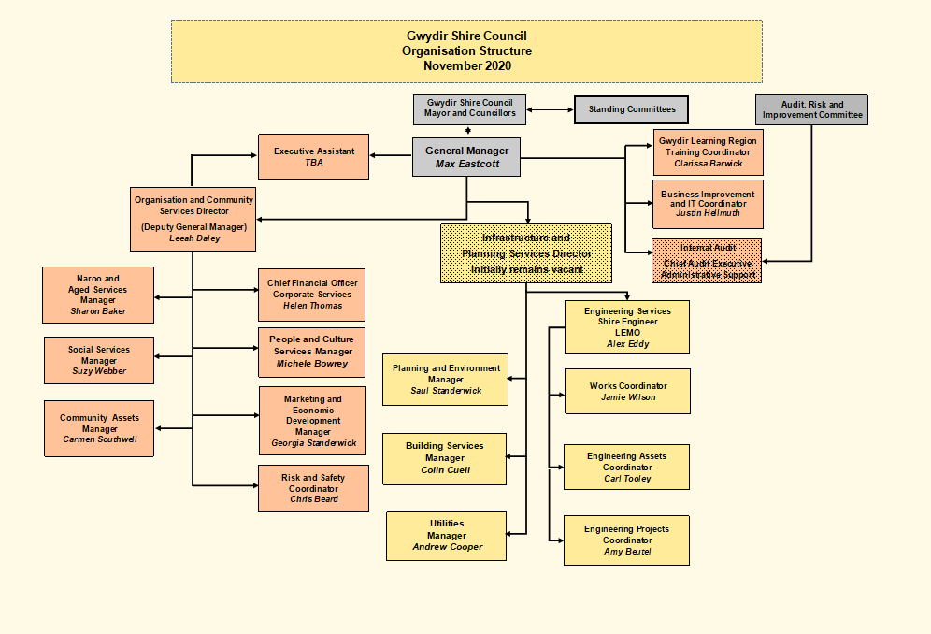
Signature Block

Prepared by | Human Resource Officer
Approved by General Manager
(or delegate) – Name:
Approved by General Manager
(or delegate) - Signature:
Date Approved/Reviewed:
Version Number and Date: | Version 3 – February 2021
Employee Declaration
I agree with and understand the requirements of my employment with Council, as contained in this Position Description.
I declare that I:
- have had the opportunity to ask questions regarding my terms and conditions of employment and received satisfactory responses.
- understand that the Position Description describes in general the nature of my employment and that other duties may be required of me from time to time consistent with my position classification level, experience, and qualifications.

Employee Name (Please Print):
Employee Signature:
Date:

