Request for Quotation

This document outlines the conditions of responding to this RFQ. Respondents are cautioned to carefully read any and all instructions, terms and conditions of contract and fully understand Council’s requirements outlined within this RFQ.
Failure to adhere to these instructions and terms and conditions may result in your submission being rejected.

RFQ Title Bingara Preschool Upgrade
RFQ Number GWY _2021_Q10
Issue Date 26/03/ 2021

RFQ Closing Time and Lodgement Details
RFQ Closing Date: | 30/04/2021
RFQ Closing Time: | 17:00
RFQ Lodgement: | Please return your quotation electronically via email to swebber@gwydir.nsw.gov.au - Mark subject as “Bingara Preschool Extension”
Hardcopy RFQ: | Gwydir Shire has now moved to electronic procurement. Submissions may only be received electronically and must be received by the advertised closing time to be considered for evaluation.
RFQ Questions: | Any questions regarding the work required in the Request for Quotation (RFQ) document should be made to: -  NAME: Mrs Suzanne Webber  POSITION: Social Services Manager  PHONE: 02 67242071  EMAIL: swebber@gwydir.nsw.gov.au
Evaluation Criteria: | Methodology, Ability to meet time frame, Capability, Workplace Health and Safety, Relevant Experience, Environmental Sustainability and Benefit to the Local Region.

Detail to Include in Quotation
Item | Detail
1 | Price (bill of materials and labour) including discounts or incentives
2 | Project Delivery Conditions
3 | Respondent Details
4 | Any other relevant details relating to the supply of goods/services
5 | The successful supplier will be required to effect and maintain insurance policies in the following sums:  - Workers Compensation (Statutory and common law liability for death or injury to persons employed by the contractor);  - Public Liability Insurance in the sum of at least $20,000,000 in respect of any one occurrence;  - Products Liability Insurance which covers all Vehicles, Plant, Products and Materials;  - Comprehensive Motor Vehicle and CTP Insurance required for all vehicles to be used on worksite and/or to be driven on Public Access Roads
6 | The successful supplier may be required to provide documents and information listed below prior to commencement:  - Trade Licence (i.e. Builders Licence)  - Safety Management Plan or equivalent  - Environmental Management Plan or equivalent  - Risk Management Plan or equivalent

- Introduction
  - Details of Gwydir Shire Council
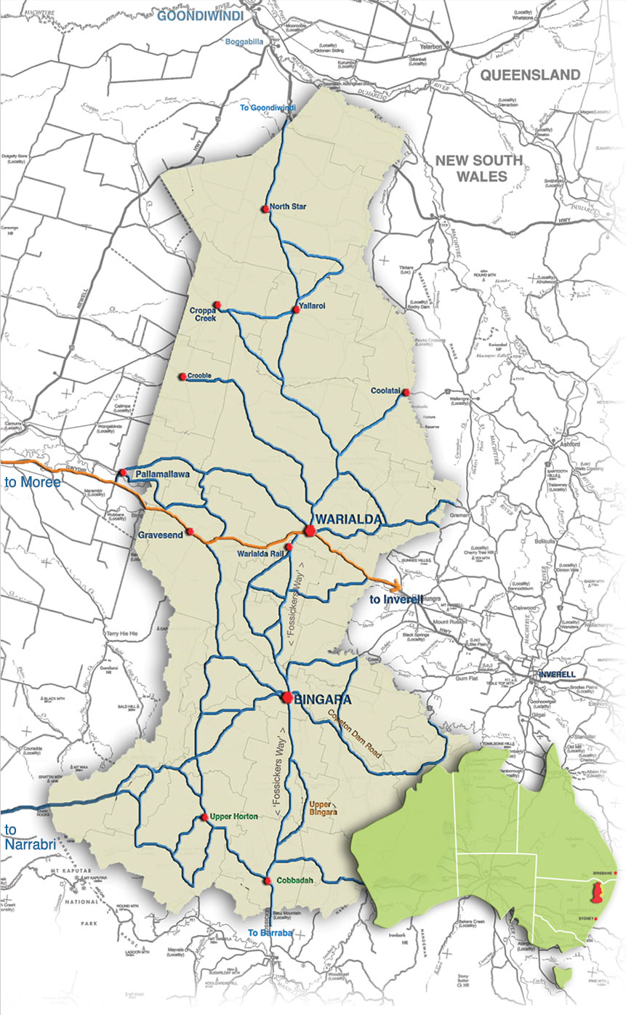
Gwydir Shire is located on the northwestern slopes and plains of NSW, approximately 560 kilometres north of Sydney, 160 kilometres north of Tamworth, 430km south west of Brisbane, 85 kilometres west of Inverell and 80 kilometres east of Moree. Incorporating an area of 9,122 square kilometres, the Shire extends from the Nandewar Range in the south, north to close to the NSW-Queensland border.
The Shire has two small towns - Bingara and Warialda, 5 rural villages – North Star, Croppa Creek, Coolatai, Gravesend and Upper Horton and 21 rural localities – Boonal, Blue Nobby, Yallaroi, Crooble, Pallamallawa (part) Balfours Peak, Warialda Rail, Gineroi, Bangheet, Riverview, Elcombe, Pallal, Rocky Creek, Back Creek, Cobbadah, Gundamulda, Dinoga, Gulf Creek, Upper Bingara, Keera and Copeton.
Agriculture is the primary land use and economic activity of the Shire. Cattle and Sheep production are the main activities, along with broadacre cropping. At 2016 Census, the Shire had a population of 5,258 and like many Shires with a high-level dependency on agriculture, has experienced a population has declined over the past 15 years. In order to reverse this trend, diversifying its economic base will be key to ensuring growth in the future.
Through this RFQ, Council intends to award contracts to Suppliers who can support Council in delivering the best service possible to its community.
Gwydir Shire Council is committed to the highest standards of honesty, fairness and integrity in all its business dealings. Council’s Statement of Business Ethics sets out the standards that it expects from its private sector partners in order to deliver exceptional service to the community.
I look forward to your participation in the RFQ and invite you to work with us in achieving Council’s objectives.

Max Eastcott
General Manager
Gwydir Shire Council

Hovell Street
(P O Box 923)
WODONGA VIC 3689
Ph: (02) 6022 9300
Fax: (02) 6022 9322
Hovell Street
(P O Box 923)
WODONGA VIC 3689
Ph: (02) 6022 9300
Fax: (02) 6022 9322
Hovell Street
(P O Box 923)
WODONGA VIC 3689
Ph: (02) 6022 9300
Fax: (02) 6022 9322
  - About the Funding Programme
The funding for this project has been secured through the NSW Department of Education Start Strong Capital Works Grants Program and is specific to Bingara Preschool.
  - Summary of the Request
Gwydir Shire Council (the Principal) is seeking Submissions from appropriately qualified and experienced contractors for this project.
  - RFQ Timetable
The timetable below provides details of key events and dates with regards to this RFQ process. Dates may vary.
Event | Date
RFQ Release | 26/03/2021
Mandatory Site Visit | By appointment
Clarification and Questions Close | 23/04/2021
RFQ Closes | 30/04/2021

A RFQ Briefing / Site Inspection will not be held however contractors are asked to arrange site inspections by contacting Suzanne Webber on 0427241931
- Scope of Work
  - Background
Council has secured funding to undertake the addition of a room to the Bingara Preschool
  - Objective
The aim of this project is to improve the functionality of the Bingara Preschool to accommodate the regulations regarding the education and care of children. These changes will create a more functional space for the service and the community.

  - Specification/Project Brief
The scope of works for this RFQ is for the provision of all materials, services and labour required to construct fencing and fire doors. The works include, but may not be limited to;
- Demolish existing ramp entry and roof gable end.
- Relocate existing sun shade and remove tree.
- Relocate hot water unit and yard tap, remove section of fence and relocate gate.
- Remove doorway and adjacent window.
- Form new entry with all ability access.
- Relocate existing window to office south wall and form counter to new hallway.
- Include accessible bathroom.
- Construct new classroom extension as detailed
- Installation of any other required fixtures

Note: All works are to comply with relevant Australian and council standards, and be as per the attached plans and specification.
The Contractor is responsible for all relevant clean-up and disposal of waste.

- Schedule of Prices
This schedule may be used for the purpose of progress claim assessment and as a basis for negotiations for variations under the contract. It does not form part of the specification or scope of work. The Respondent shall be responsible for the completion of all contract activities and this schedule shall not restrict completion. Line items against which no amounts are stated, whether quantities or rates are given or not, shall be regarded as covered by other line items in this schedule. This schedule shall be read in conjunction with all other parts of the contract.
Quoted prices must allow for all plant, materials, profit, payroll tax and other loadings on all wages and for any fees, royalties, premiums, costs, charges and the like which will be due or payable to any person or authority for the undertaking of this service. No claim may be made for any expenses incurred in the preparation of the quotation. Quotations are to be valid for a minimum of sixty (60) days from the quotation closing date.
Note: Contractor is required to provide a bill of quantities detailing items that have been priced and allowed for in their submission. All pricing is to remain fixed for the period of the contract, not subject to rise & fall and be exclusive of GST.

Add additional lines in the below table as required

Item | Description | Qty | Unit | Rate | Quoted Amount  (Ex GST)
1 | Construction Elements
 | Earthworks  • Clear site  • Footings  • Drill piers |  |  | $ | $
 | Demolition  - relocate shade  - remove tree |  |  | $ | $
 | Concreting  - peers and footings  - trench mesh |  |  | $ | $
 | Brick laying  • Bricks  • Mortar  • Tie down  • Ant capping |  |  | $ | $
 | Sub floor  • Bearers 125x75 F5 cypress pine  • Joists 100x50 F5 cypress pine  • Wet area step down 50mm  • Particle board flooring 19mm particle board  • Wet area Compressed flooring 19mm |  |  | $ | $
 | Framing  • External walls 90x35 MGP10 T2 framing pine  • Internal walls 90x35 MGP10 T2 framing pine  • Bracing Ply 2400x1200x4  • Soffit framing 70x35 MGP10 T2 framing pine  • New opening to classroom from craft room |  |  | $ | $
 | Trusses and roofing  • Trusses installed to manufacturers design at 900c/c  • Fascia to match existing  • Roofing iron, barge capping, ridge capping, flashings to match existing  • Guttering and down pipes to match existing |  |  | $ | $
 | Windows and doors  • Windows to match existing. W1 Relocate  • External door 1 920x2040x40 solid core to be selected  • External door 2 half glass panel size to be confirmed  • Internal door 3 and 4. 920x2040x35 semi solid  • Door hardware to match existing |  |  | $ | $
 | Cladding  • Weather board to match existing  • Soffit linings to match existing  • Stops to match existing  • External architraves to match existing |  |  | $ | $
 | Plumbing  • Provide surface interception drainage to high side of building  • Rough in  • Fit off  • Relocate hot water system |  |  | $ | $
 | Electrical  • Connect hot water system  • Down lights  • Ceiling fans  • Light switches  • GPO  • Switch board upgrade |  |  | $ | $
 | Insulation  • Wall insulation R2 batts  • Ceiling insulation R2 batts |  |  | $ | $
 | Internal linings  • Gyprock walls 10mm  • Ceiling mounted furring channel  • Gyprock ceilings 10mm  • Villaboard 6mm wet area linings  • 90mm cove cornice |  |  | $ | $
 | Bathroom  • Concrete floor screed  • flooring  • wall linings |  |  | $ | $
 | Access ramp/ Stairs & Landing  • Concrete mesh, ties N12 bar, chairs  • Sand to back fill  • Concrete slab, landing and stairs  • Steel fabricated handrails to meet access requirements |  |  | $ | $
 | Fit out  • Skirting to match existing  • Architrave to match existing  • Store room shelving. |  |  | $ | $
 | Painting  - Internal  - external |  |  | $ | $
 | Floor coverings |  |  | $ | $
2 | Install (Labour) |  | hours | $ | $
Total (Ex GST) |  |  |  | $ | $
3 | Minus Discounts or Incentives (optional)
GRAND TOTAL (Ex GST) |  |  |  | $ | $
Lodgement of a Submission will itself be an acknowledgement, the Respondent
- is submitting a proposal and offers to carry out the services named, shown and described in the RFQ; and
- further promises and agrees, in the event of the proposal being accepted, to be bound by the Request for Quotation and the submitted proposal.
- Is responsible for understanding the work required as council will not be responsible for additional costs incurred.

Respondent’s Statement
"I certify that this submission is made without prior understanding, agreement or connection with any corporation, firm or person submitting a submission for the same materials, supplies, or equipment, and is in all respect fair and without collusion or fraud. I agree to abide by all conditions of this RFQ and certify that I am authorised to sign this submission for the Respondent.”
Respondents Authorised Representative Name
Date
Quotation Total (Inc. GST)
Respondents Authorised Representative Signature
- Project Delivery
Suppliers are required to submit all information requested in the specification and request for quotation to enable the Council to assess their ability to carry out the Services. This questionnaire has been prepared to assist you in supplying this information.
  - Methodology
- You are required to provide a construction program and provide details of the methodology for this project. Summarise the key/milestone dates for the construction in the below table.
Task/ Milestone | Details | Commencement Date | Completion Date
Investigation
Mobilisation
Construction(Individual Stages/Structures)
Practical Completion
Site Clean-up

  - Ability to Meet Timeframe
- Supply/provision of the specified goods or services to be completed by, 30th June 2021.
Can you complete works by this date? Yes □ No□
If no please comment:
__________________________________________________________________________________

- Do you have any current projects that may affect the completion date for this project?
Yes □ No□
If yes please comment:
______________________________________________________________________________________

- What equipment does the contractor own at present that will be available for this contract and what other resources does the contractor propose to utilise in the completion of this contract?
Number /quantity | Description of plant or classification of labour | Plant owned/hired/hire purchase? | Labour now employed or to be recruited?

- Has your organisation failed to complete a contract? If so, when, where and why (provide details)?
__________________________________________________________________________________

- List names and telephone numbers of three professional referees
Name | Position | Organisation | Telephone

- Respondent Details
Suppliers are required to submit all information requested in the specification and request for quotation to enable the Council to assess their ability to carry out the Services. This questionnaire has been prepared to assist you in supplying this information.
  - Respondent Details
In submitting this quotation, I acknowledge that I have read the specification and can provide the services as nominated.

Respondent’s Information
Company Name
ABN
Business Address
City / Town
State
Post Code
Office Phone
Email Address
Website
Respondents Contacts Detail
Name
Mobile Phone
Office Phone
Email Address
  - Ownership
If your organisation is a company, provide details on your ownership, including the ownership of parent/holding companies and subsidiaries. State whether these companies are Australian based. Name each shareholder holding 20% or more of your issued share capital, paid-up capital and other relevant details. Alternatively, if your organisation is a partnership, provide a list of partners and details of the partnership financial arrangements. Each party to the consortium is to respond to this question.
Response – Ownership Details
  - Experience
- How many years’ experience have you had in the type of work required to perform under the contract?
Experience – years: _______

- Key staff and qualifications - What is the experience of the principal staff of the contractor in the type of work it would be required to perform under this Contract?

Name and position | Location and description or work and for whom work performed | Qualifications

- List the details of proposed sub-contractors to be utilised in completion of the works.

Sub-Contractor Name | Works to be performed

- List work of similar type that the contractor has currently underway or recently performed.

Description of contract, value and location | For whom contract performed | Contact details | Commencement and completion dates

  - Risk and Insurance
- If short listed, will you be able to supply a copy of your current Certificate of Currency for Public Liability and Workcover Insurance? Yes □ No□

- If no, Council will be unable to use your services

- In what other type of business has the Supplier a financial interest?
__________________________________________________________________________________

- List two banks or other financial institutions from which references may be obtained.

Contact name | Financial Institution | Telephone

  - Additional Information
- Please provide any further information regarding your submission that you believe need to be taken into consideration when your submission is evaluated

__________________________________________________________________________________________

__________________________________________________________________________________________
  - Workplace Health & Safety

- Who will be the on-site WHS leader for your company throughout this job?

__________________________________________________________________________________

- What will be your WHS audit and inspection schedule on-site throughout this job?

__________________________________________________________________________________

- From the information available what if any hazards have you identified as a part of this job and how will you manage these?

__________________________________________________________________________________
  - Environmental Sustainability

When evaluating offers, consideration needs to be given to the impact that the goods and or services has on the environment. Also, purchases are based on the principle of Value for Money and should therefore consider the total cost of ownership or whole of life costs (acquisition, operation, maintenance, use & disposal) of the product and/or service. The Council will consider the following environmental sustainability criteria: reduce, reuse and recycle.

- Please provide details of environmental policies and plans with evidence of their application: and or

__________________________________________________________________________________

- Please provide examples of practices and products that demonstrate a commitment and capacity to deliver positive environment outcomes.

__________________________________________________________________________________

  - Benefit to the Local Region
The implementation of Social Procurement is empowering Councils to realise they can use their buying power to generate positive social outcomes for their communities, on top of getting the best value for goods and services. As a result, Gwydir Shire Council is expecting potential suppliers to show how they can help promote the economic and social wellbeing of the community. This expectation will vary between Councils and often depends on the type of contract being tendered. Examples of Social Procurement are as follows:
- Employing local workers;
- Employing economically disadvantaged and socially marginalised constituents;
- Using local sub – contractors;
- Using local accommodation;
- Using local suppliers or materials.

- Does your business have a head office, if yes, where is it located and is this different from the depot/ operations office(s)?
__________________________________________________________________________________

- What percentage (%) of your company staff are based in the Gwydir Shire region and what percentage (%) of staff are based outside the region?

__________________________________________________________________________________

- What percentage (%) of materials, plant and equipment will be sourced or manufactured in the Gwydir Shire region?

__________________________________________________________________________________

- What impact can your business offer of the local community? i.e. sponsorship(s) of sporting groups, youth services or community organisations, or employment and training opportunities for minority groups? Or are you a social enterprise, indigenous business, minority owned business, volunteer organisation or disability firm? Please explain?
_____________________________________________________________________________

